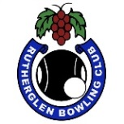 RUTHERGLEN BOWLING CLUB
PRESENTS
Opening day for season 2019-2020
Gold coin donation to charity for spider
then
2 bowls triples or fours depending on numbers.
Teams selected by match committee
Sunday September 8th
1pm start. Names in by 12 noon
Visitors welcome.
Bowls Australia approved uniform to be worn.
(New bowlers neat casual)
All members please bring a plate.
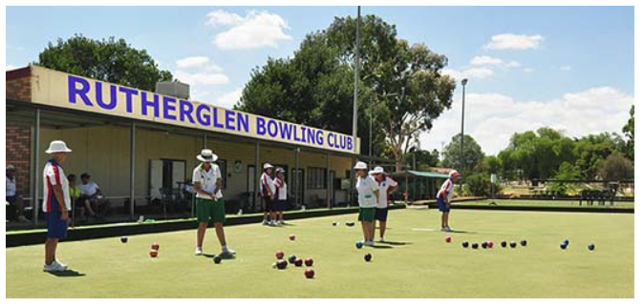

Contact: Rutherglen Bowling Club: 0260 329 252. Match committee Chair: Glenice Campbell 0408 420 508

