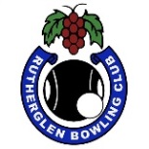 RUTHERGLEN BOWLING CLUB
PRESENTS
“BOWLING WITH BUDDIES”
In memory of
Russell Towner & John Pearce

OPEN TRIPLES S/O
All men, all women or mixed teams
Sunday 19th January
3 games of 10 ends
1pm start. Entries close 10am on the day
Place names on the list at the clubhouse
or phone clubhouse – 02 6032 9252

