[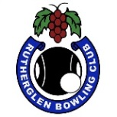](https://www.facebook.com/1394169440840526/photos/a.1394177464173057.1073741825.1394169440840526/1412878662302937/?type=3) **RUTHERGLEN BOWLING CLUB**

**PRESENTS**

**Aylean and the late Ed Baker Mixed Triples**

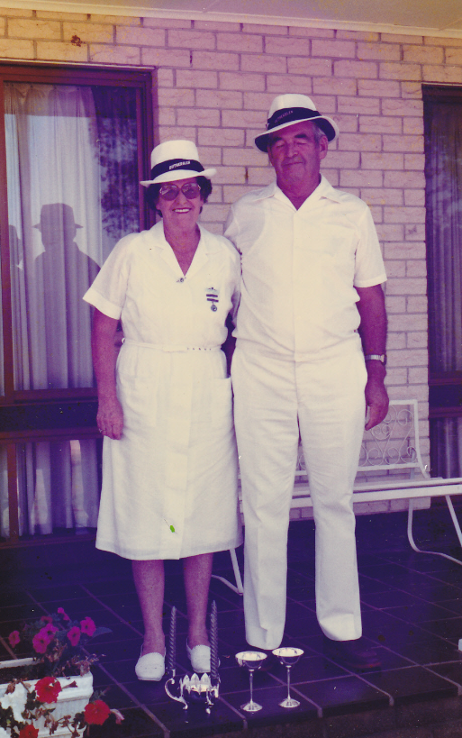

**Sunday 12th January. 1 pm start**

**3 Games of 10 ends.**

**5 end playoff for 3 game winners**

**Entries close 10am on the day**

**Place names on the list at the clubhouse**

**or phone clubhouse – 02 6032 9252**