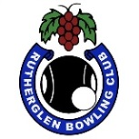 RUTHERGLEN BOWLING CLUB
PRESENTS
Wighton Gravel
Mixed 2 Bowl Triples O/H
(Teams selected by match committee)

Sunday 2nd February. 1 pm start
3 Games of 12 ends.
Cost $10 per person
Members bring a plate
Winners selected by games won and shots up
Entries close 10am on the day
Place names on the list at the clubhouse
or phone clubhouse – 02 6032 9252

