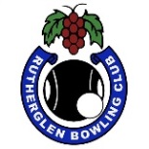 RUTHERGLEN BOWLING CLUB
PRESENTS
Hargraves Ambrose & Co
Lawyers and Solicitors
and
Wighton Gravel
Mixed 2 Bowl Triples
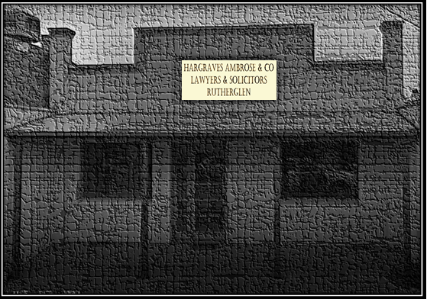

Sunday 14th November. 1 pm start
3 Games of 10 ends.
Entry fee $30 per team. Total prize money $645
Winners selected by games won and shots up

Entries close Saturday 13th November at 6pm. Single entries welcome
Place names on the list at the clubhouse
or phone clubhouse – 02 6032 9252

All players and spectators must be fully vaccinated.
All conditions and catering subject to the Covid directives at the time

Further information contact Glenice Campbell, Match Committee Chair
Phone 0408 420 508

