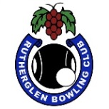 RUTHERGLEN BOWLING CLUB
PRESENTS
LORNA BAKER MEMORIAL
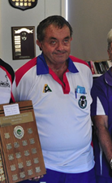
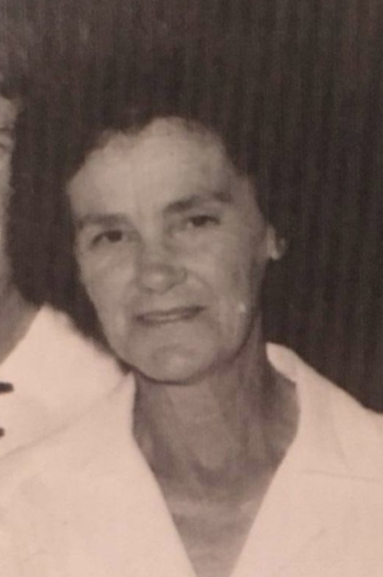
MIXED PAIRS
Sunday 28th November
1pm start

3 games of 10 ends
3 bowls
5 end play off for 3 game winners

Entry fee: $20 per team
Entries close 6pm Saturday 27th November
Entry sheet on the board at the club or ring 0260 329 252
Entry for fully vaccinated bowlers only
All conditions and catering subject to the Covid directives at the time

Proudly sponsored by Jamie Baker and his sister, Annette Eagland

For further information contact Glenice Campbell, Match Committee Chair
Phone: 0408 420 508

